

Kevin & Melissa’s
Investment Progress Review

Prepared by Roshan

7th August 2023
Table of Contents
Introduction & Background 2
Change in Portfolio Value 4
Portfolio Investment Detail 7
Suitability Review 8
Costs & Charges 10
Important Information 12
Client Declaration 13

Introduction & Background
Further to our meeting of 7th August 2023, I am writing to review the suitability of your investments.
As part of your ongoing service, I review your investments to determine whether they continue to remain suitable for your needs and objectives.
This review is limited to the investments that I manage for you (e.g. your Parmenion accounts). You may have other needs that have not been addressed in this report. This report should be considered alongside previous advice reports.

Your Circumstances
During our meeting, we discussed your personal, family and work circumstances, the economic environment, your attitude towards risk/return and the performance of your investment holdings over the course of the past year and over your holding period. We also discussed the health pandemic and geopolitical issues, and the resulting economic challenges that have subsequently developed. My advice is based on the details you provided during our discussions and is detailed later in this report.
This is your sixth annual review meeting after engaging Frazer James to arrange Kevin & Melissa’s pension and investment assets with Parmenion in March 2017. Our review meetings have taken place each year since then, with our last meeting taking place 11 months ago in Sep 2022. This year our ‘meeting’ took place by video call via Microsoft Teams. In advance of our meeting, we supplied you with a presentation pack of the arrangements that we look after which you managed to study before the meeting commenced.
You have both remained in good health and were in reasonable spirits when we spoke. Since we put your investments in place it has been an uncertain period for markets. I am pleased that you have been disciplined and have remained invested in markets/funds.

Risk Profile
During our recent review meeting, you jointly completed a new investment risk profile questionnaire.
This suggested an overall risk score of 7/10 (equivalent to investing 61% - 70% equity, with the remainder in defensive assets, such as bonds and cash). As things stand, you are currently invested 53% equity and 47% bonds/cash, equivalent to investing at risk score 6/10.
Having reviewed this in the context of your overall financial plan, I recommend increasing slightly the level of risk you take with your investments. Doing so may improve the returns you receive over time, which in turn can help to reduce the potential shortfall in your financial plan.
Once the changes have taken effect, you will be invested 63% equity overall, an increase of 10% equity compared to how you are currently invested. The below table summarises the change to the level of investment risk I recommend:
Account | Value | Current Equity | New Equity | Change
Melissa Parmenion Drawdown | £40,233 | 40% | 50% | +10%
Melissa Parmenion ISA | £17,211 | 40% | 50% | +10%
Melissa Parmenion Pension | £110,213 | 60% | 70% | +10%
Kevin Parmenion Drawdown | £49,112 | 40% | 50% | +10%
Kevin Parmenion ISA | £50,977 | 40% | 50% | +10%
Kevin Parmenion Pension | £389,219 | 60% | 70% | +10%
Total | £656,966 | 53% | 63% | +10%

Your objectives
We discussed and agreed the below objectives for you:

Maximize life's potential and secure a financially abundant retirement.

Attain the flexibility to retire comfortably within a few years while maintaining financial stability throughout retirement.

3. Optimize investments to achieve growth aligned with your risk tolerance and financial goals.
Change in Portfolio Value
The below summarises how your portfolio has changed in value between 25th October 2021 and 27th June 2023. This represents the total period of time I have advised you on your investments.
Account | Start Value* | Money In/Out | End Value* | Profit/Loss
Melissa Parmenion Drawdown | £0 | £35,721 | £40,233 | £4,512
Melissa Parmenion ISA | £0 | £20,121 | £17,211 | -£2,910
Melissa Parmenion Pension | £0 | £132,102 | £110,213 | -£21,889
Kevin Parmenion Drawdown | £0 | £51,251 | £49,112 | -£2,139
Kevin Parmenion ISA | £0 | £51,216 | £50,977 | -£238
Kevin Parmenion GIA | £0 | £721 | £0 | -£721
Kevin Parmenion Pension | £0 | £421,612 | £389,219 | -£32,393
Total | £0 | £712,745 | £656,966 | -£55,779

Melissa’s Valuation History
The below summarises how the value of your accounts has changed over time:
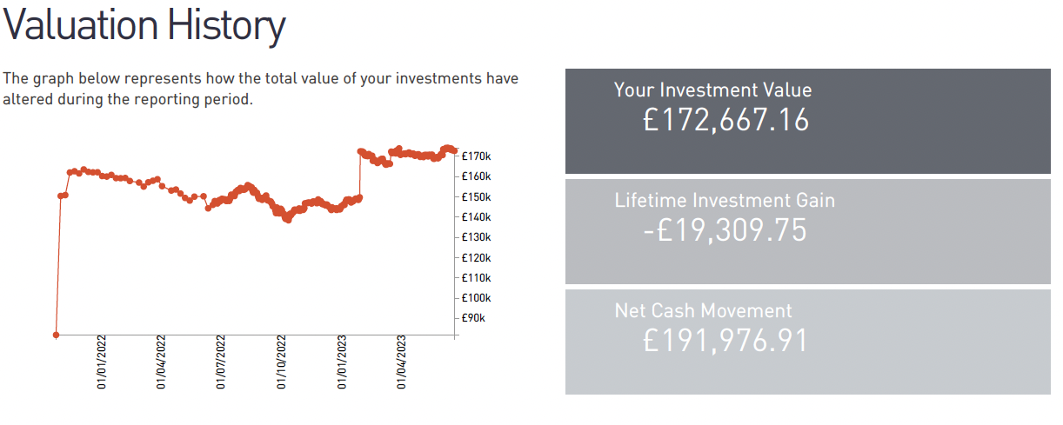

Kevin’s Valuation History
The below summarises how the value of your accounts have changed over time:
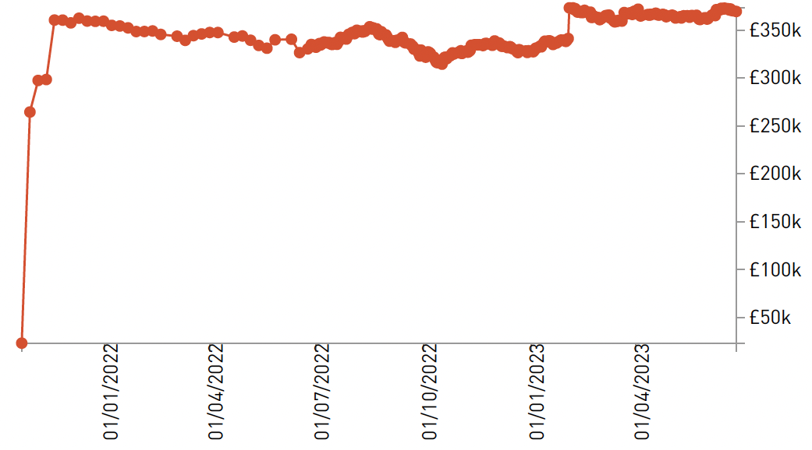

Portfolio Investment Detail

Asset Allocation Overview
The below summarises your overall asset allocation, across your entire portfolio. There are approximately 52.9% growth assets in your portfolio, which have the potential to grow more but come with a higher risk of volatility, and 47.1% defensive assets, which tend to be more stable when investments fall in value.
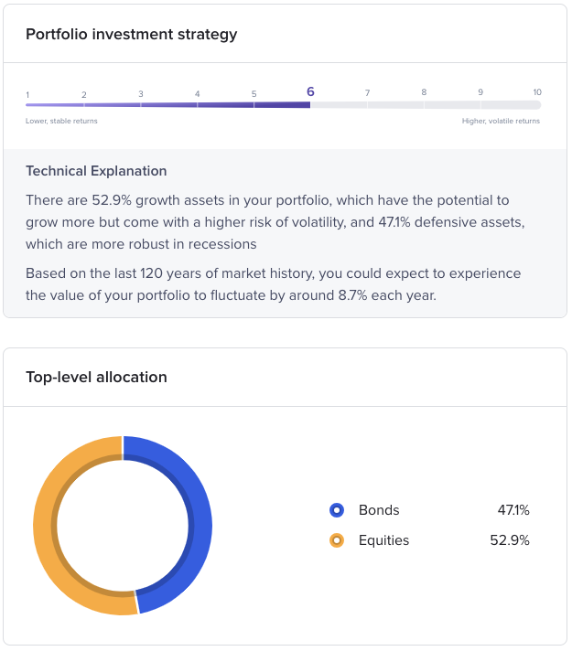

Investment Breakdown
Your accounts invest in the Vanguard LifeStrategy fund range, with the:
- ISAs and Drawdown Pensions investing 40% Equity / 60% Bonds
- Pensions invests 60% Equity / 40% Bonds
For further information, please refer to the below links:
- Vanguard LifeStrategy 40% Equity Portfolio
- Vanguard LifeStrategy 60% Equity Portfolio

Suitability Review
As part of your ongoing advice service, I regularly review your arrangements to ensure they are suitable for you. The results are below:
Account | Provider | Strategy | Costs | Risk
All Accounts | Suitable – no changes required | Suitable – no changes required | Suitable – no changes required | Changes recommended

Provider
After researching the market, I continue to believe that your current investment provider remains suitable as:

Backed by financial strength and extensive market experience.

Proven track record of exceptional client servicing.

Offering a diverse range of investments to tailor a portfolio to your risk profile.

Payments
You are not making any contributions or withdrawals from your investments.

Strategy
I have reviewed how your money is invested and confirm that the strategy remains suitable for your needs. I recommend sticking with the current strategy as:

Designed with a closely monitored asset allocation tailored to match your risk profile.

Offers exposure to various asset classes and market sectors, ensuring enhanced diversification and minimized risk.

Managed continuously, reducing paperwork and administrative burden.

Utilizes solely index-tracking funds, keeping charges at a minimum.

Demonstrates strong performance compared to its benchmark.

Cost
I have reviewed how much you pay in costs and confirm that the current charges provide value for money. The overall costs are deemed to be suitable as:
- Offers cost-effective solutions compared to alternative investment strategies.
- By keeping costs low, it allows you to retain a higher portion of potential investment returns.

Risk
As discussed in the introductory section, I recommend increasing the level of investment risk you take. Each account will increase the investment risk by approximately 10% equity. For further information, please refer to the below documents. Please note, that the fund weightings may differ slightly from the portfolio analysis if the portfolio has not been rebalanced recently.
- Portfolio Analysis - Vanguard LifeStrategy - 40% vs 50%
- Portfolio Analysis - Vanguard LifeStrategy - 60% vs 70%
There are no one-off charges for making these changes. You will pay ongoing charges. These are summarised in the charges section. The investment costs for new the risk profile are broadly the same as your current risk profile (plus or minus 0.01%).

Summary
With the recommended changes to the risk profile, I consider your investments to be suitable for your needs and objectives. I do not recommend any further changes. It is important to review your investments regularly to ensure they remain suitable.

Potential Risks & Drawbacks
The below table summarises the potential risks and drawbacks to your investments:
Drawback | Further Info
Charges | As the value of your investments increases, the charges you pay will also rise proportionally, as they are calculated as a percentage of your investment amount.
 | Therefore, when paying adviser charges from your accounts, it will have an impact on the overall value of your fund, potentially reducing it over time.
Risk | During the transition period when your risk profile is being adjusted, there might be a brief period when your account remains uninvested. If investments increase in value during this time, you may miss out on potential gains.
 | Some of your accounts may involve higher investment risk than before, causing them to experience more significant fluctuations in value.
 | Conversely, other accounts may involve lower investment risk, resulting in a more stable but potentially lower overall return.
 | Your investments include overseas assets, and any fluctuations in exchange rates can impact the value of your investments.
 | Given that you are invested in emerging markets, these investments are considered higher risk compared to more conventional options.
 | It's essential to acknowledge that the value of investments can both rise and fall, and there is a possibility that you may get back less than what you initially invested.
 | Inflation can also affect the purchasing power of your investments over time.
Performance | The actual investment returns you receive may be lower than the ones presented in illustrations.
Access / Control | Since you are invested with a Discretionary Fund Manager, you won't be consulted on any changes made to your investments; they will be managed on your behalf.
 | Parmenion is a platform designed for advised clients. If you choose to take a do-it-yourself approach later, you may have limited access to your investments. To gain complete control over your investments, you might need to transfer to a different provider.
Drawdown Costs | Facilitating drawdown involves a significant amount of administration, leading to higher charges compared to purchasing an annuity.
Taxation | Funds held within your ISA will be considered part of your estate for inheritance tax purposes.

Costs & Charges
As part of their general annual reporting, product providers are required to provide you with a detailed breakdown of the exact charges that have been applied to your account in the previous year. For details on the charges, you have paid over the review period, please refer to these documents. A copy is available on request.
The below summarises the total cost of your investment portfolio over the next 12 months. It is based on the value of your investments as of 5th July 2023, which may differ from the values reported earlier in this report. It assumes that:
- The recommended changes to your risk profile are implemented.
- The investment strategy remains unchanged.
- There is no investment growth observed.
There are no initial charges, only ongoing charges. These are provided below:
 | Melissa Parmenion Drawdown |  | Melissa Parmenion ISA |  | Melissa Parmenion Pension
Plan Value | £40,105 |  | £20,372 |  | £121,228
Contributions / Withdrawals | £0 |  | £0 |  | £0
Platform Charge | 0.30% | £122 | 0.25% | £51 | 0.30% | £367
Investment Charge | 0.27% | £108 | 0.27% | £55 | 0.26% | £315
DFM Charge | 0.00% | £0 | 0.00% | £0 | 0.00% | £0
Adviser Investment Fee | 0.50% | £201 | 0.50% | £102 | 0.50% | £606
Adviser Planning Fee | 0.00% | £0 | 0.00% | £0 | 0.49% | £600
Total | 1.07% | £431 | 1.02% | £208 | 1.59% | £1,828

 | Kevin Parmenion Drawdown |  | Kevin Parmenion ISA |  | Kevin Parmenion Pension
Plan Value | £47,306 |  | £37,135 |  | £301,962
Contributions / Withdrawals | £0 |  | £0 |  | £0
Platform Charge | 0.27% | £130 | 0.25% | £93 | 0.27% | £830
Investment Charge | 0.27% | £128 | 0.27% | £100 | 0.26% | £785
DFM Charge | 0.00% | £0 | 0.00% | £0 | 0.00% | £0
Adviser Investment Fee | 0.50% | £237 | 0.50% | £186 | 0.50% | £1,510
Adviser Planning Fee | 0.00% | £0 | 0.00% | £0 | 0.20% | £600
Total | 1.04% | £494 | 1.02% | £379 | 1.23% | £3,725
Combined together, total charges are expected to be £7,125 (equivalent to 1.25% of the overall portfolio value). The cost in £s is estimated, the actual cost will be confirmed to you each year by your investment providers. Where charges are taken on a percentage basis, the amounts will fluctuate in line with your investments. For further information, please refer to your investment illustrations and management report.
Please note that due to system limitations, the above documents do not include the annual retainer charge of £1,200 deducted from your Parmenion pensions.

Important Information

Assumptions
This advice is based on my understanding of your circumstances and objectives. If anything is incorrect, please let me know as soon as possible as it may affect the advice you have received.
Any comments made in this report about the tax position of a particular asset or strategy are based on my understanding of current law and HM Revenue & Customs practice. This may be subject to change in the future.
Valuations within this report were supplied by your existing providers and are assumed to be correct. These are not guaranteed and will fluctuate in value.

Client Classification
You have been classified as a Retail Client. Retail Clients are afforded the highest level of regulatory protection available.

Ongoing Reviews

As part of your ongoing service, I will review the suitability of your investments annually to ensure they remain appropriate to your needs and goals. I will contact you in August 2024 to arrange your next review.

Next Steps

The next steps are summarised below:
Action | Who | When
Electronically sign this advice report | Kevin & Melissa | ASAP
Update the risk profile for your accounts:  ISAs & Drawdown Accounts = 50% Equity  Pensions = 70% Equity | Frazer James | Aim: 10 working days
Yours sincerely,
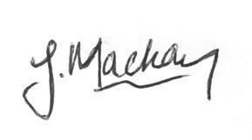
James Mackay
BSc CFP™ Chartered MSCI
Managing Director & Financial Adviser

Client Declaration
I have read this report and received all the accompanying documentation outlined in the Important Information section.
I accept that the advice is based on the information I have provided and confirm that the recommendations contained within this report are a fair reflection of my circumstances and objectives.

Signature __________________________ Date ____/____/____

Kevin

Signature __________________________ Date ____/____/____

Melissa

